The Liionidas Open Baffle speaker.
Everything you need to know to build a set.
Lii Audio makes beautiful fullrange drivers. The Crystal-10 being their flagship driver. So, when Lao Lii designed an open baffle woofer, the W-15, they asked me to design a nice open baffle with these 2 drivers and so I did.
The only way to judge my design, was to do their own build in China, which has been done.
As well me, and also Lao Lii are pretty much convinced about this setup. The sound is great! Confirmed by listening sessions held both here and in China.
I do this write up, so everyone has the possibility to build a set. I do the same sketches/drawings I sent to China and many photos to see construction details.
First about room position.
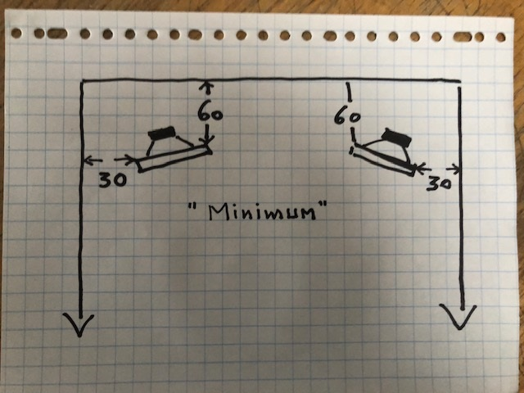
Always keep the minimum distance!! This gives a total (60+30=) 90 cm. I prefer a total of 140~160 cm.
I like a ctc distance about 250 cm for the speakers in my room.
Feel free to experiment.
This is about the largest play room you are going to have.

Second about the cabinet/construction.
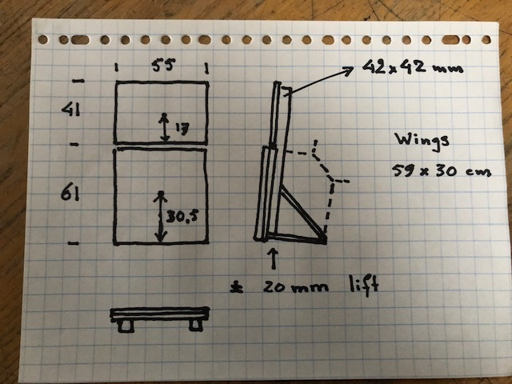
-----------------------First Alert--------------------
Stay as close as possible to: driver position, baffle dimensions. Do not change anything!! As always the construction, in my designs is the acoustic part of the cross-over!!
The airgap between the 2 baffles is 4 or 5 mm.
My square wood pieces are 42x42 mm, anything between 40 and 45mm will do okee.
Keep them away from the sides the thickness of your wings.
Have 18mm ply for top baffle and wings and 2x18mm mdf for the woofer baffle.
I use those iron bookshelf carriers to make a 90 degrees rigid angle.
Look at the photo’s for further explanation.

Now 2/3 of the cross-over is (acoustically) ready and we only need a few parts to make everything work as it should.

The Cross over (XO).
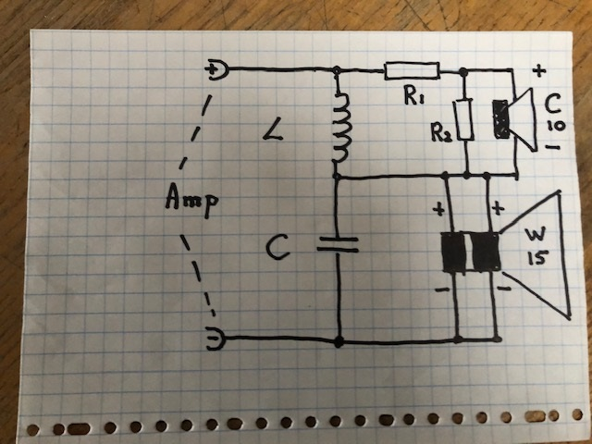
For the W 15 we use both voice coils in parallel.
Make R1 removable!!
Best results, gave the values :
L = 5,6 mH , low Rdc (about 0,2 ohm).
C = 68 uF (or 2x33uF in parallel). Good quality recommended!
R2 = 2,2 ohm , 20 watt.
R1 = 6,8 ohm , 20 watt.

I did a second “dummies” drawing:
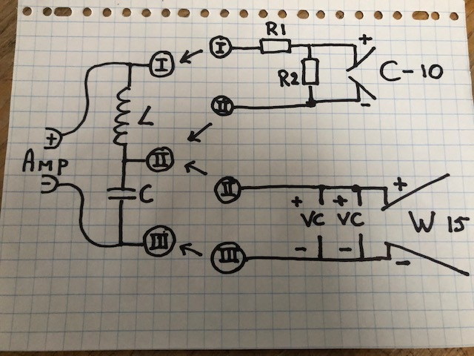

Now I will do many pictures about the way I did things.
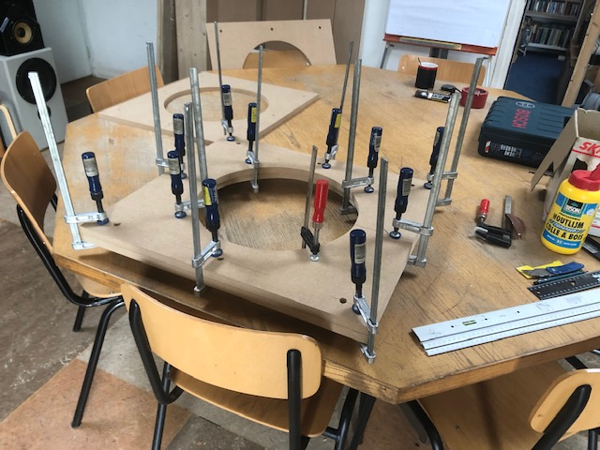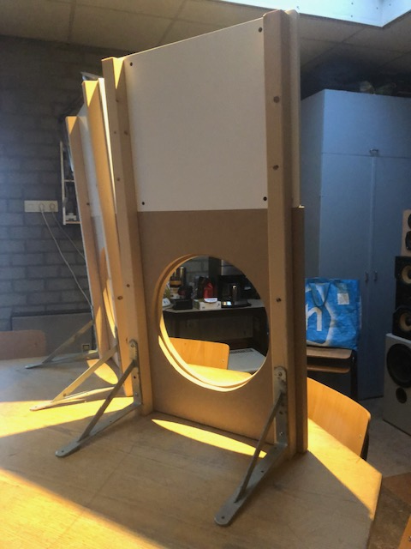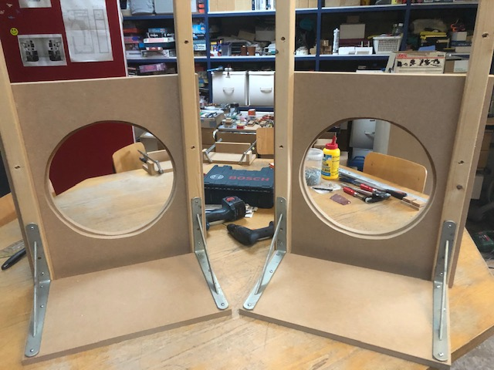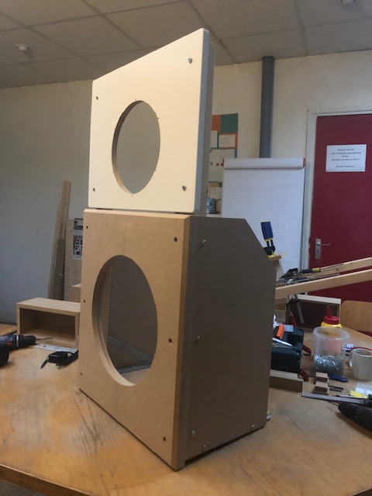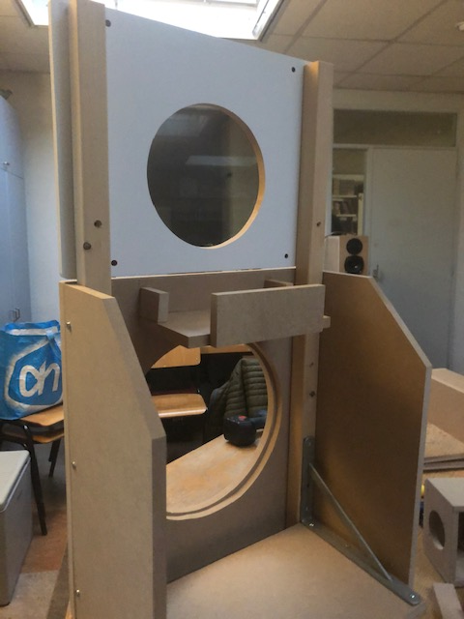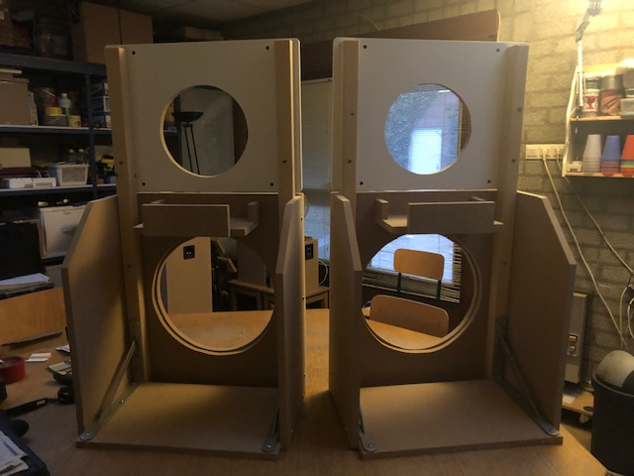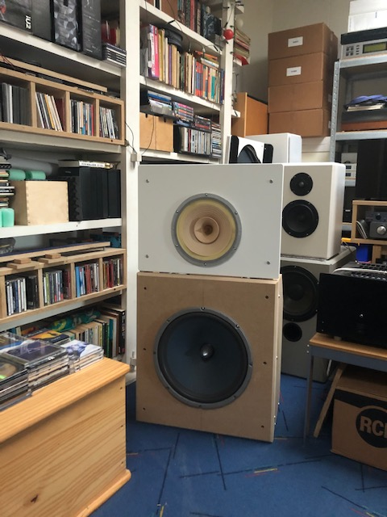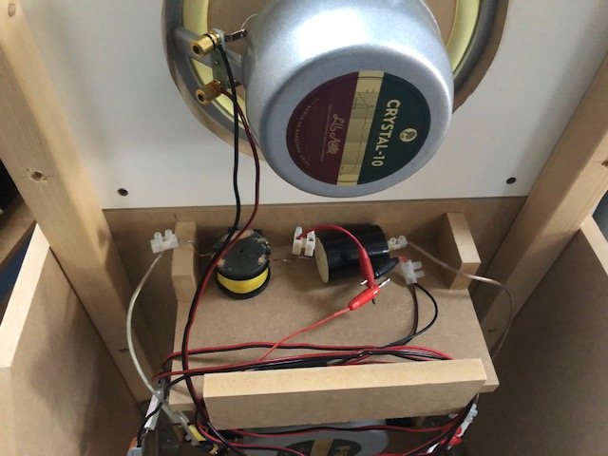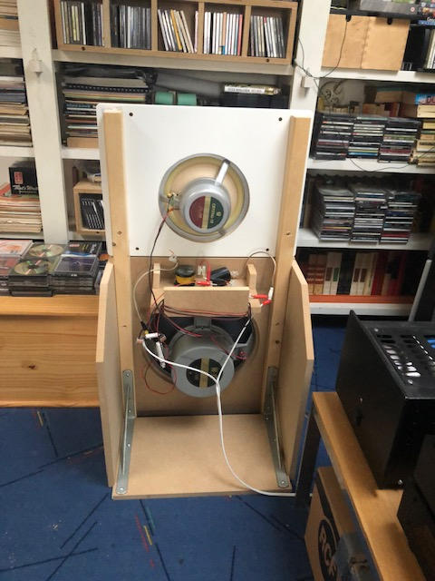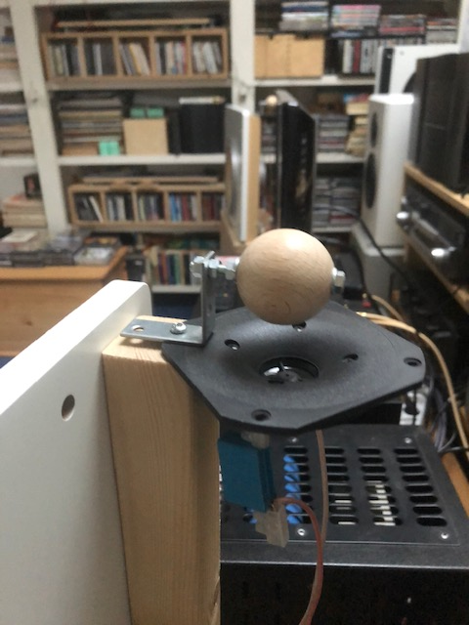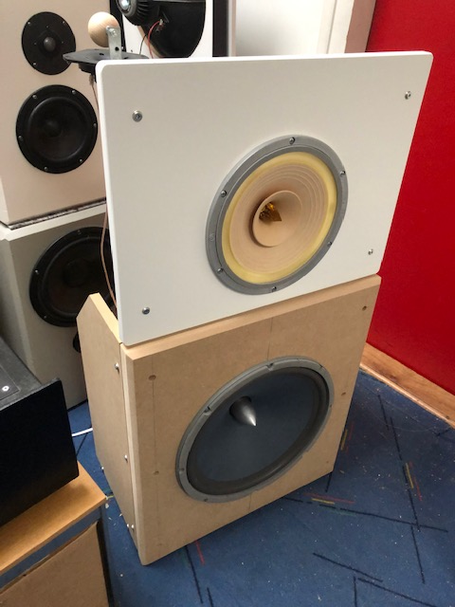

I wish you all good luck!
This is an easy build I suppose?
And YES, I will answer some questions.
And last: about the name Liionidas Open Baffle. We joined two names : (Lao) Lii and (Le)onidas.
Ad 1 I use an ambient (horizontal) tweeter and I like it very much. Gives, in my room , some more reflected sound and by that a “better” 3 dimensional sound. So, feel free to do your own experiments.
Ad2 My dear friend Frank van Beek suggested to use a silverfoil cap, in parallel with the 68uF. About 0,5 uF silverfoil capacitor. And also: take a wirewound R for R1 because being in the signalpad of the Crystal 10.
Ad3 This set is built in China and approved by Lao Li and a bunch of friends coming for listening session.
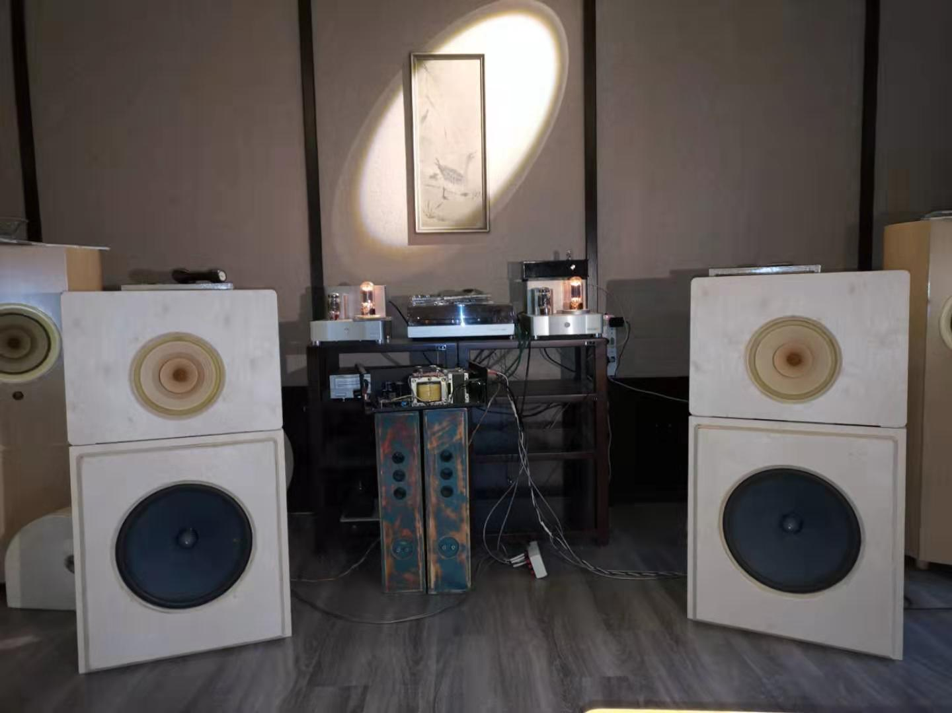
Leon (Leonidas) Huijgen.

