FusionAmp delay measurement between Master and a Slave unit, coupled by SPDIF. Audio signal is applied to Master on AES, S/PDIF and Optical. FusionAmp gain=0dB, flat filter.
Sample frequency of FusionAmp = 93750Hz
Analogue out
Analogue out
SLAVE
MASTER

S/PDIF

AES, SPDIF, Optical

Master input AES:
- Burst sine, -20dB
- F=10kHz
- 96kHz sample frequency
Output Analogue:
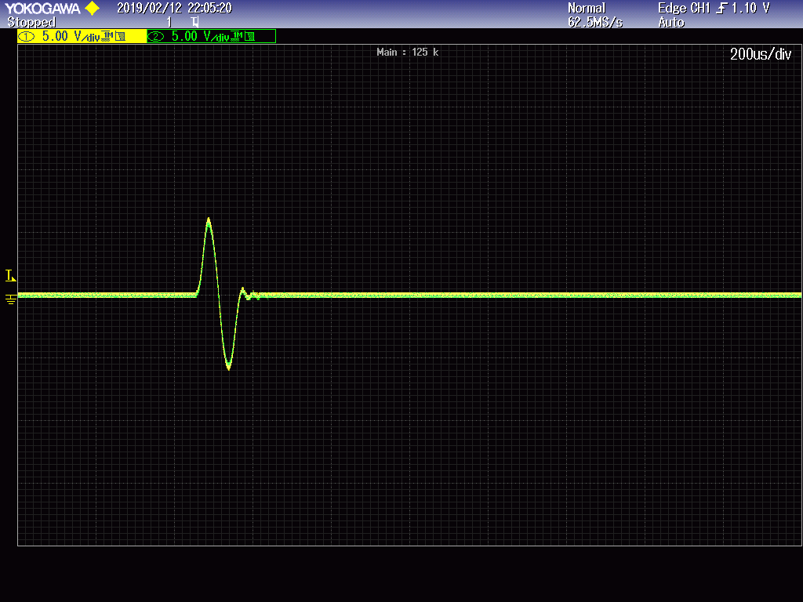
Enlarged:
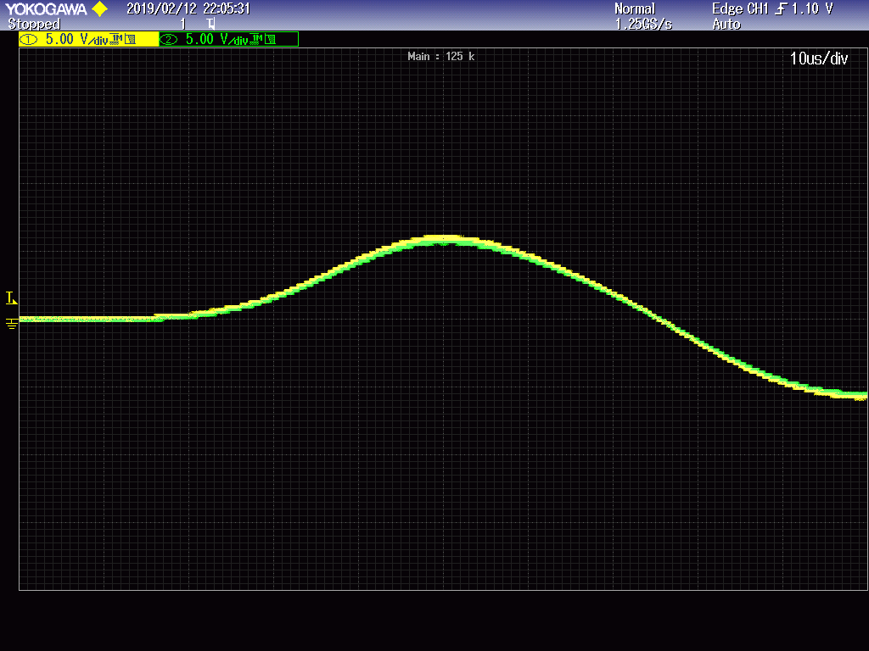
Looking at the graph above, no delay is seen between the yellow (master) and green (slave) curve.
Test: When the signal in the Master is delayed by one sample, the screen is looking as follows:
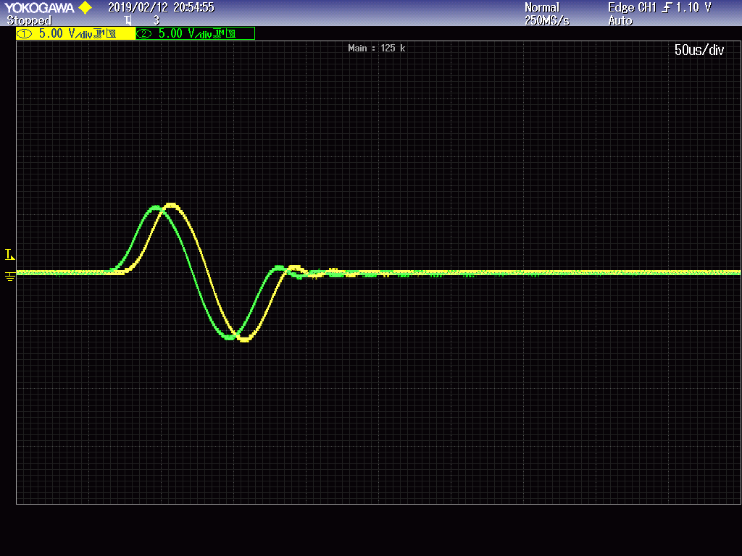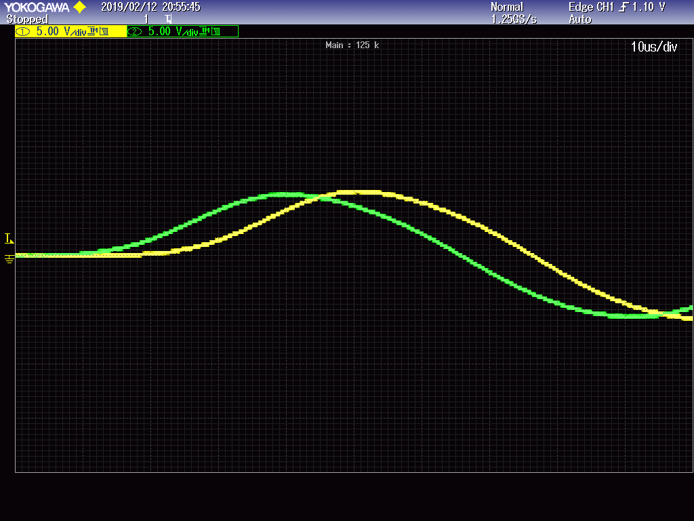
Exactly 10.6us, which is 1/93750 (sample frequency = 93750Hz)

Master input AES:
- Burst sine, -20dB
- F=10kHz
- 48kHz sample frequency
Output Analogue:
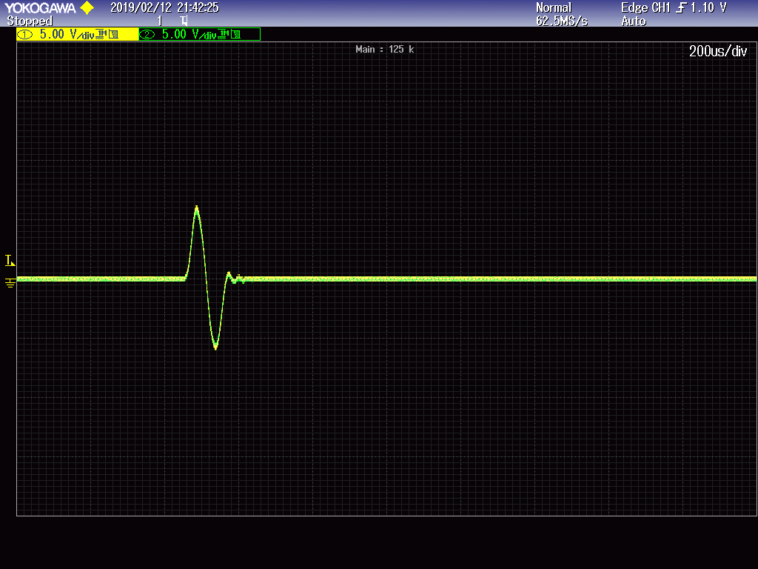
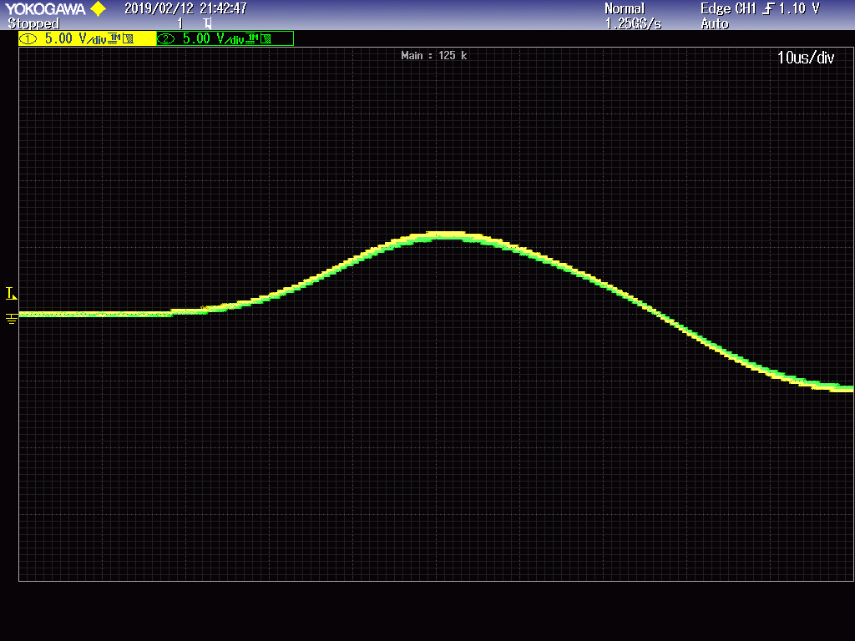
No difference between 96kHz and 48kHz sample rate.
Master input S/PDIF:
- Burst sine, -20dB
- F=10kHz
- 96kHz sample frequency
Output Analogue:
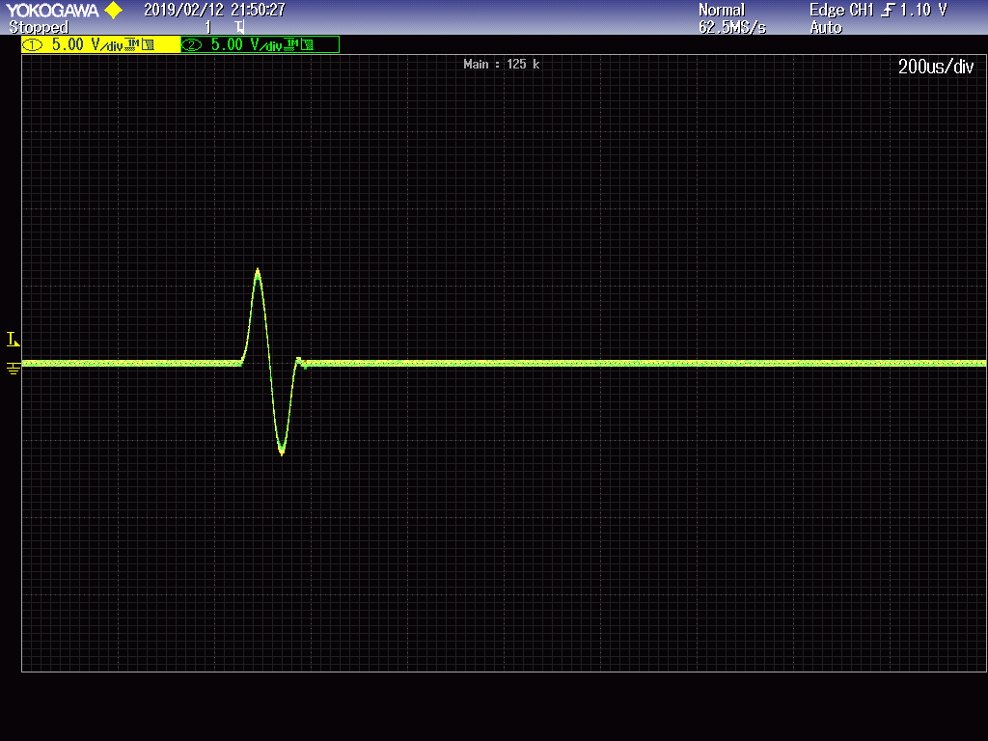
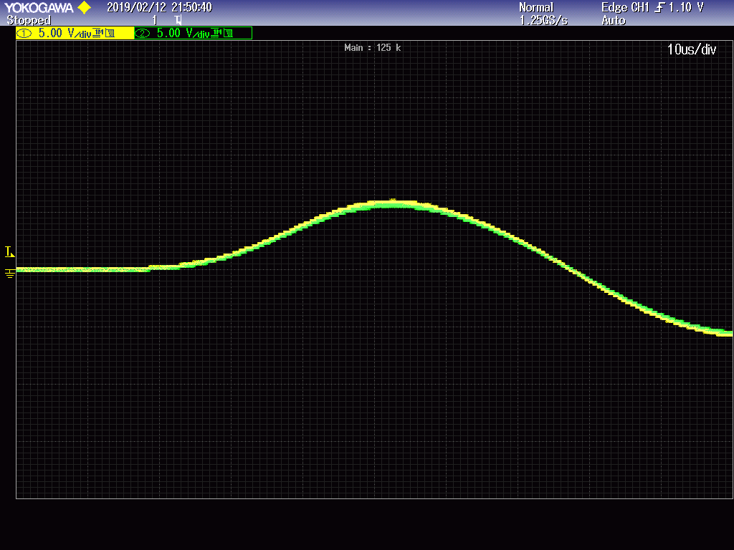
Again, no delay seen here, converting S/PDIF to S/PDIF
Master input Optical:
- Burst sine, -20dB
- F=10kHz
- 96kHz sample frequency
Output Analogue:
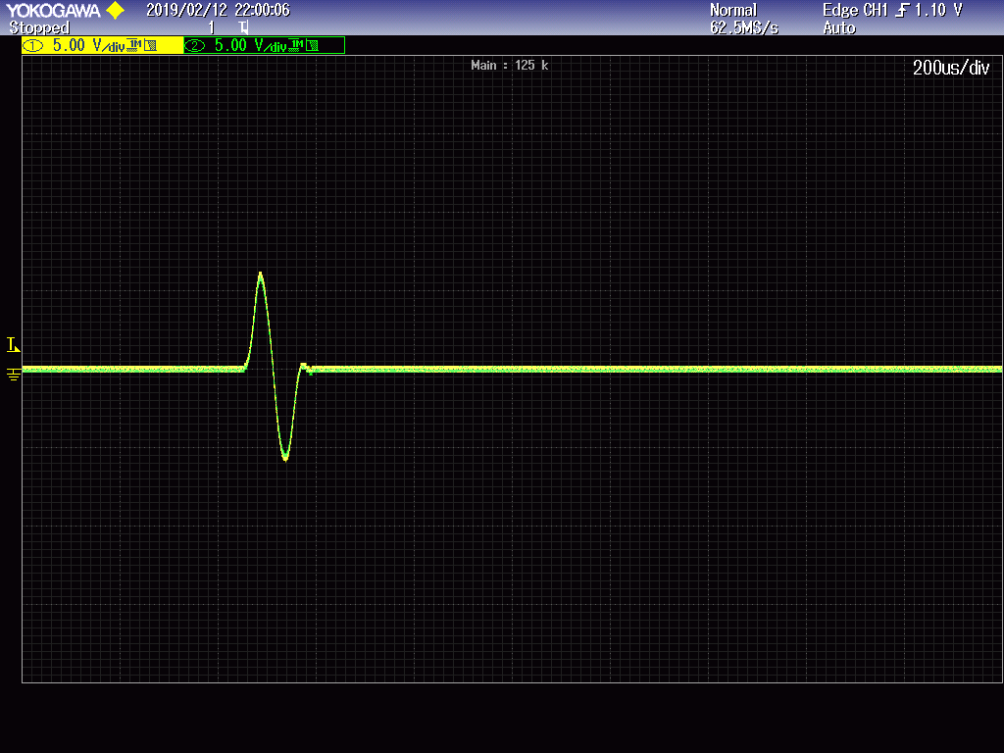
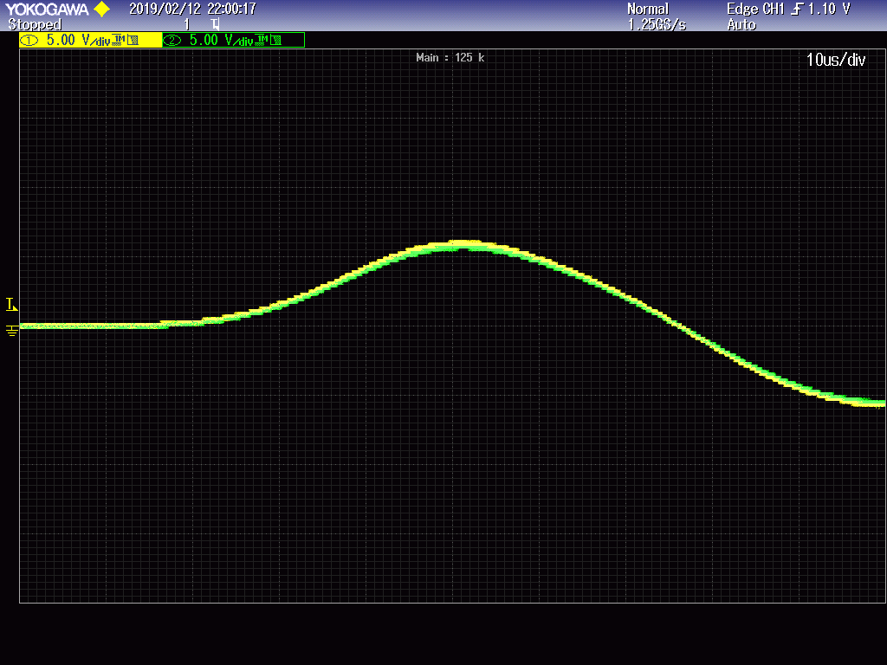
No delay here, converting toslink to S/PDIF

