
4-4-2016
Pureaudio Project - Trio15 Lowther DX3 with "Leonidas" crossover review
by Maarten van Druten
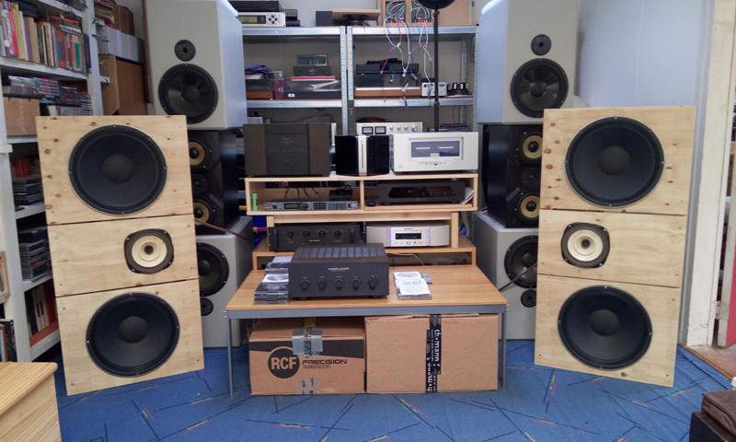
My current loudspeakers are more then 20 years old now, they served me very well but now it's time for something new.
So currently I have started my quest to find new loudspeakers.
In the loudspeaker world, the choice is enormous, tranmissionline, line array, dipole, bipole, full-range wide banders, or magnestatic loudspeakers?
I have listened to many different loudspeakers during my life, but there was never one loudspeaker that really made me smile...
They all had concessions at some point, one speaker had a very nice projection and sound-scape but was lacking deep bass, the other was sounding very nice but has a sweet spot that was so narrow that if you moved your head only a few centimeters the sound scape collapsed
On the X-Fi high-end show 2016 I heard the active “daudio W1” dipole loudspeaker, that loudspeaker made in Netherlands really made me smile!
This loudspeaker has an “Mundorf” dipole air motion tweeter hanging in the air with wires that was sounding very, very good.
The music was transparent, it's was everywhere, even if you turned your head all around it was if there was a big cloud of music was hanging in the room, the bass was also very good, with lots of definition, deep but certainly not muddy
The only disadvantage was it's price for 17.500 euro a pair, this speaker was too expensive for my budget.
One of the audio developers told me that they were working on a smaller passive version of this speaker in the 5.000 euro range.
That sounded as music in my ears, but then I have to wait...
Because it is uncertain when this new speaker will be released, I don't know if I can wait so long...
Pureaudio Project: "Leonidas crossover"
Then I read an article on the Internet about the “Pureaudio Project”.
Pureaudio Project has designed an modular open baffle loudspeaker, that is very affordable.
According the few review on the Internet their sound was something special, and they sounded much better than commercial high end loudspeakers costing even four times more
And they won many “Best of Show” awards.
They have multiple models, two caught my interest the Trio 15 Voxactiv with Leonidas crossover and the smaller Trio 10 with an Mundorf air motion tweeter.
I became very interested in this concept, and I wanted to listen to this special loudspeaker.
After some searching on the Internet, luck was smiling to me, because one of the crossover designers of the Pureaudio Project loudspeakers was living close to my neighborhood!
So I contacted him, I introduced myself and asked if it was possible to listen to this
Pureaudio Project loudspeakers.
Leon Huijgen responded quickly and invited me to his design studio!
I was very excited, and I can not remember when the last time that I got excited to listen to loudspeakers
Leon was already waiting for me at the door when I arrived. I introduced myself, and Leon was very friendly. He showed me around in his studio were he designs and tests his loudspeakers and crossovers.
Leon Huijgen is an loudspeaker designer that designs loudspeakers not from a technical starting point but from experience, and just to practical listening.
This practical approach comes also back in his crossover designs.
For the Pureaudio Project has Leon designed a very interesting crossover that is adjustable.
It can be easily adjusted to someones preferences or to the room or both.
This crossover is called the "Leonidas crossover"
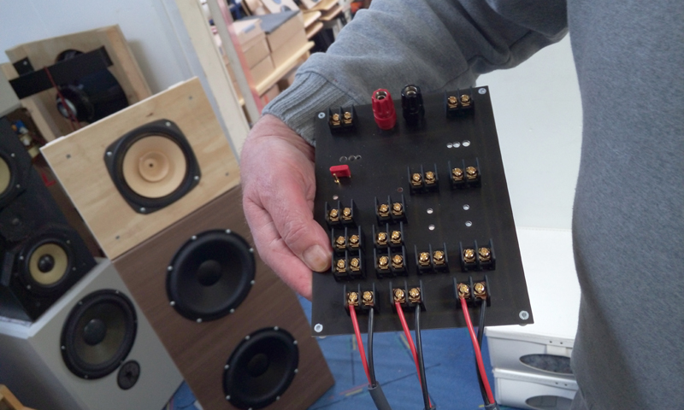
The Leonidas crossover

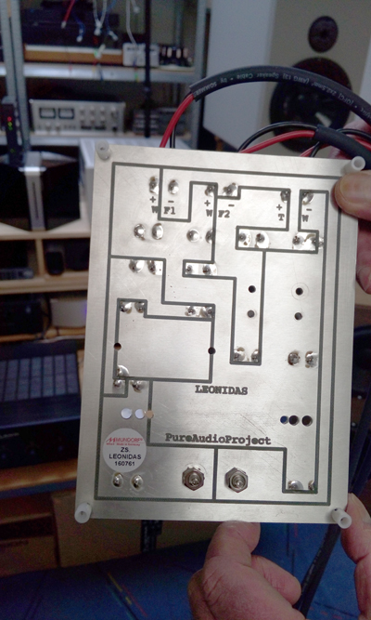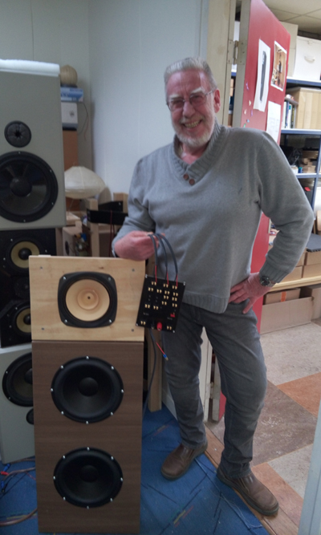
The designer himself "Leon Huijgen"with his creation the "Leonidas crossover"
Lowther DX3
When I entered his listening room two Pureaudio Project TB 15's were already warming up.
I was very excited to listen to them, because I have never heard them before.
Leon explained that he used the “Lowther DX3” widebander loudspeaker unit in this Trio 15 setup.
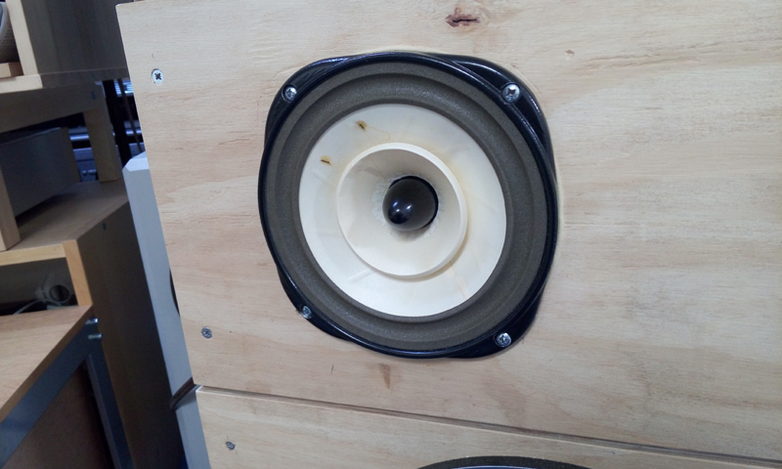
The Lowther DX3 widebander in the Pureaudio Project Trio 15
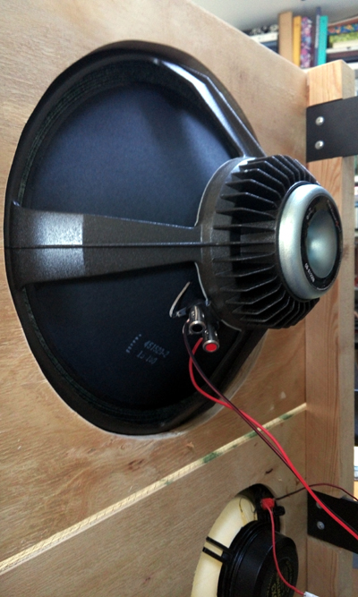
The Lowther DX3 from the back, and of the OB-A15neo woofers!
Of course the “Leonidas Crossover” was also present in this setup
For this listening session Leon used a Marantz SACD player and a Jungson JA-88D Class A Integrated Amplifier
We played many different music numbers from a compilation CD
How does the Pureaudio Project Trio 15 with Lowther DX3 sound?
First of all, after reading reviews of others I was a little afraid that the bass would be absent.
This was absolutely not the case, bass was certainly there, and it was fast, tight, and well balanced.
The sounds was very transparent and the projection into the room was very good.
One thing became very clear to me, the quality level of this loudspeaker was very high.
This speaker delivers everything without any trouble, at this price point this loudspeaker is a “steal” (in Dutch we say “geheim tip”) a insider secret, explaining that this loudspeaker preforms at an remarkable high level
Another very important thing I learned that day was, that every speakers needs a minimum power level to work optimal.
The Pureaudio Project Trio 15 can also play very loud
Before listening to this dipole loudspeaker I was used to a “boxed” loudspeaker were the sound comes only from one side, but by this dipole concept the sound comes from everywhere!
Because of this the music sounds much more realistic, “more live” and also it sounds like if the music is played much louder than normal
Then Leon played Pink Floyd at a very high level
The music sounded amazing, without trace any distortion!
Every instrument was very detailed and available without any sharpness
Leon's preferred setup was a little bit different than my preferred setting
I personally prefer the music to be played a little more quiet.
I also found that the mid tones were a little too dominant.
But this a matter of personal taste.
And this exactly were the amazing Leonidas crossover comes into place!
With this adjustable crossover the decibel settings of each loudspeaker can be adjusted in absolute phase to the preferred level!
Then Leon told me, for example that he could adjust the both Eminence OB15 NEO woofers with + 6dB so that the full range Lowther DX3 still could play on it's preferred level, and that total sound balance would more to my personal taste.
And this is terrific news, a speaker system that is adjustable to someone own preferred taste is a very big welcome in the world of High-End.
No more concessions but tailor made musical presentations just how it should be.
The modular Pure Audio Project Trio 15 project is an very adjustable system, were not only the loudspeaker units can be easily replaced or changed, thanks to Leonidas crossover now also fine tuning is possible in absolute phase!
Unfortunately Leon didn't had a Voxactiv speaker unit available for testing, because I was also very interested how this unit would sound with his crossover.
After listening to the Pureaudio Project Trio15, we listened to an Trio 10 with two Morrel 10 inch woofers and a Fostex widebander.
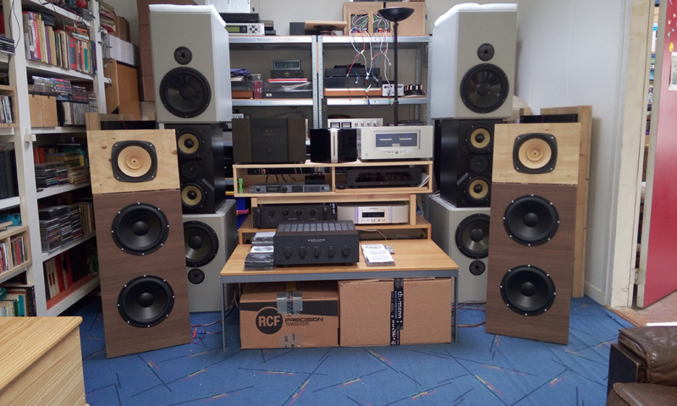
Leon's own version of the Pureaudio Project Trio 10 with Fostex widebander loudspeaker
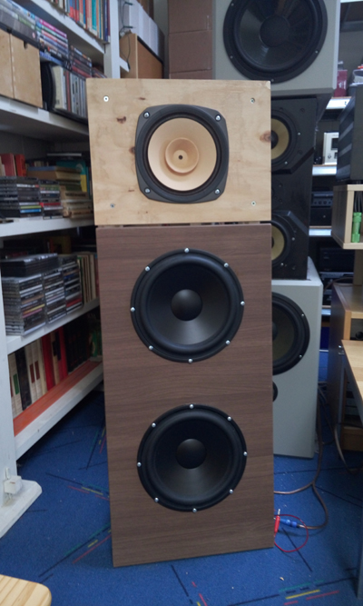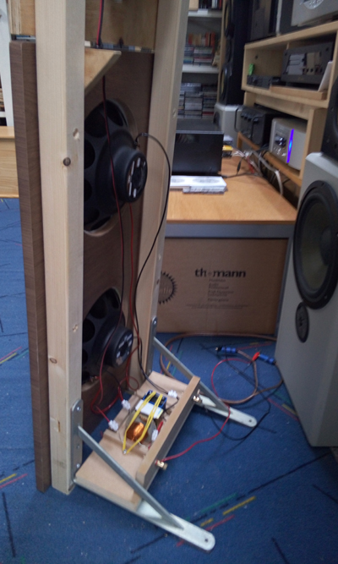
close-up from the front and back
After listening to the Trio 15 with the Lowther DX3 this was not an improvement
especially the Fostex was no mach for the Lowther DX3.
In comparison the Fostex sounded flat, clean, even a little but lifeless...
Then Leon had a nice title surprise for me!
He placed two little MDF two-way tranmissionline loudspeakers on the stands
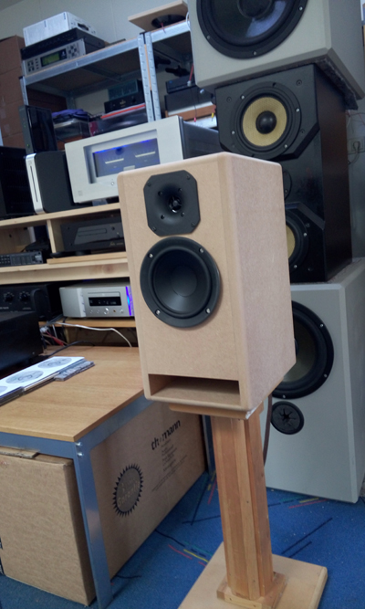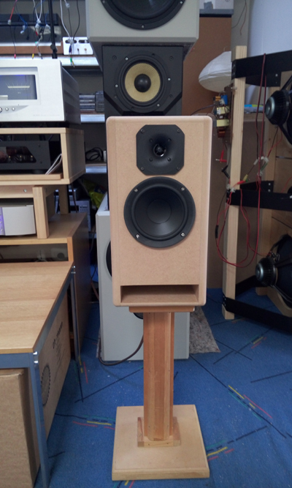
Seldom I had listened to such a musical, balanced nice loudspeaker, these little speakers sounded very, very good.
After Leon told me that this little speaker cost only 199 euro's.
I was totally amazed! He explained me that this was just a workshop speaker for students, so that they can learn how to build their own loudspeakers.
Unbelievable, this speaker sounded much better (more musical, and better balanced) than many so called high-end speakers I have heard in the shops.
Leon quality to use his own ears for his speaker designs rather than just following theoretical rules really showed off here.
For example the crossover contains only one resistor, this makes the sound so very pure and balanced sounding
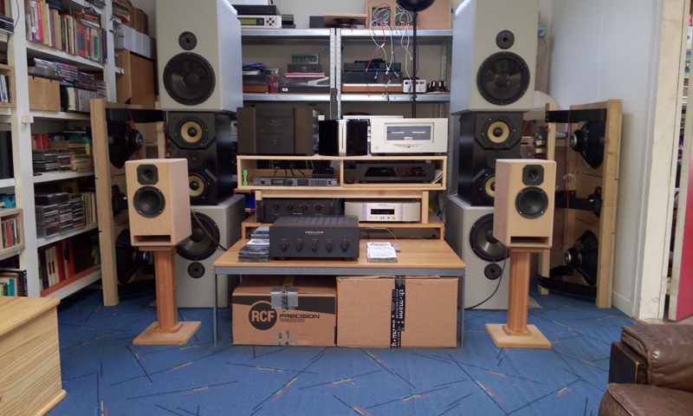
After listening to this amazing little gem, we installed the Pureaudio Project TB15 with the Lowter DX3 again
Remarkable was also the wideness of the projecting of the music from the Lowter DX3
Normally a widebander has the effect to give the music al little narrow projecting, but not this Lowter DX3, it had a better defined and also a wider sound stage.
Sometimes I could hear a strong “S” sound by some recordings but I cannot explain what was the reason of this, I only have listened this loudspeaker once.
I was very happy after this amazing demonstration of Leon Huijgen's creations
The Pureaudio Project loudspeaker are really sounding amazing, and thanks to Leon's “Leonidas crossover” the optimum result can be achieved.
Everybody has a different taste, the is no good or wrong, it's not a fight who is better.
It is all about fine-tuning the music, so you will find what sounds for you the best.
With this unique Leonidas crossover you are definitely on the right track!
Audio Dandy
P.S: Many thanks to Leon Huijgen for this hospitality and very impressive, interesting listening session
For more info about the "Pureaudio Project":
http://www.pureaudioproject.com

BACK
Copyright(C) 2015 www.maartenvandruten.com All Rights Reserved

