About X-overing an Open Baffle loudspeaker.
based on: PureAudioProject Tower Frame Kit (HW ony) and 4 X OB-A15NEO Woofers and Lowther DX3
First about me.
I’m Leon Huijgen and I live in the Netherlands.
Been building and designing loudspeakers for over 50 years.
Over time I centered my designs around the following considerations:
- the listener
- the room ( and placement)
- the front end (electronics)
- the units , loading the units and the x-over.

Being me the ‘Listener’ during the design process I call this design the Leonidas Variation on Open Baffle.
Most of the time I’m listening at medium levels of ~85/87dB and when playing loud this is about ~90/92dB.
Most commercial loudspeakers are voiced at 96 dB.
So to experience a balanced sound one always feels the urge to play louder (turn up the volume) !!
This brings us to the Fletcher & Munson curves.
When you carefully study the picture below ;
You will notice that for me , to get balanced sound experience , I’ll have to voice the x-ver to give me a rising tendency below 200Hz going to 20 Hz of , about , 10 dB !!
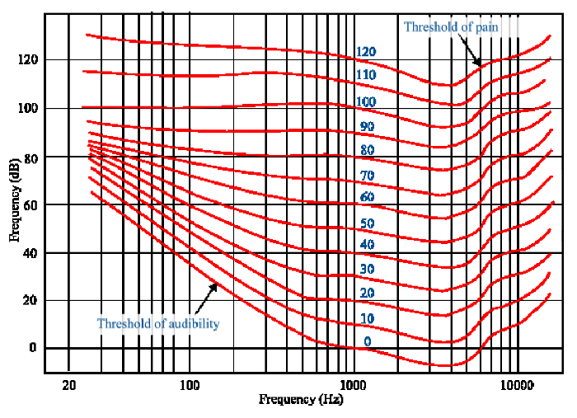

This all brings me to my starting point for an x-over .
Below you see the basic lay-out.
And the explanation how to determine the values.
I posted this before in OpenBaffleOnly. forum on Facebook
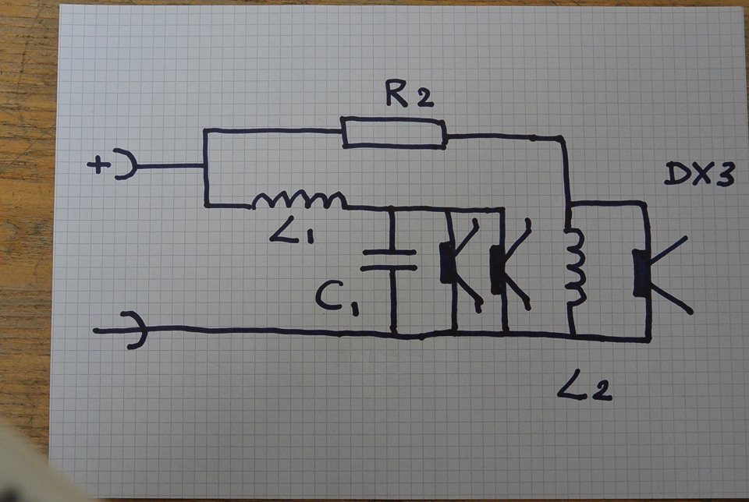

Leon Huijgen I use the Dick Olsher pics ONLY to explain some things. In this picture you see were the room gain kicks in. at about 70 Hz. In my room this is 85 Hz. this determines the value of L1.

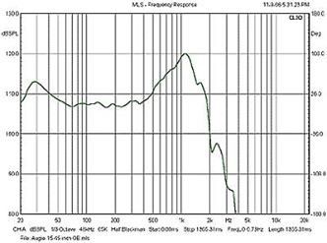

Leon Huijgen Next step is finding your minus 3db point by C1. Check by measurements at listening position.
In my case : C1 = 190 uF. (most bipolar elco with 22uF polyprop.)
Leon Huijgen Then determine L2 for the DX3 and reduce the level with R2. DC resistance of L2 has to be VERY low (in my case 0,13 ohm) And R2 NEVER lower as 18 ohm!! (At low freq. you create a shortcut.) Now you can adjust to taste (make R2 larger for finding the right balance).BTW; R2 has to be at least 20 watt and cooled; it dissipates a lot of power!!
In my case : L2 = 3,3 mH ; dcR = 0,12 Ohm.
In my case : R2 = 18 + 4,7 = 23 Ohm.
Leon Huijgen Position of the DX3 on the baffle is critical! For my taste; center at about 8 inches from the side. This gives a mild accent on upper piano and female voices (which I like). If you want it more "flat”, but still keep the DX3's sonic signature; you go to 6 inches from the side.

In my case : Because of the rising by the DX3 I added a contour in the plus of the DX3 .
I made 2 :
First 0,6 mH with 18 Ohm parallel.
Second 1,2 mH with 18 Ohm parallel ; this last one is now running !!
Made the picture below with the iPad.
At listening position ear level. Suits my taste very well !!
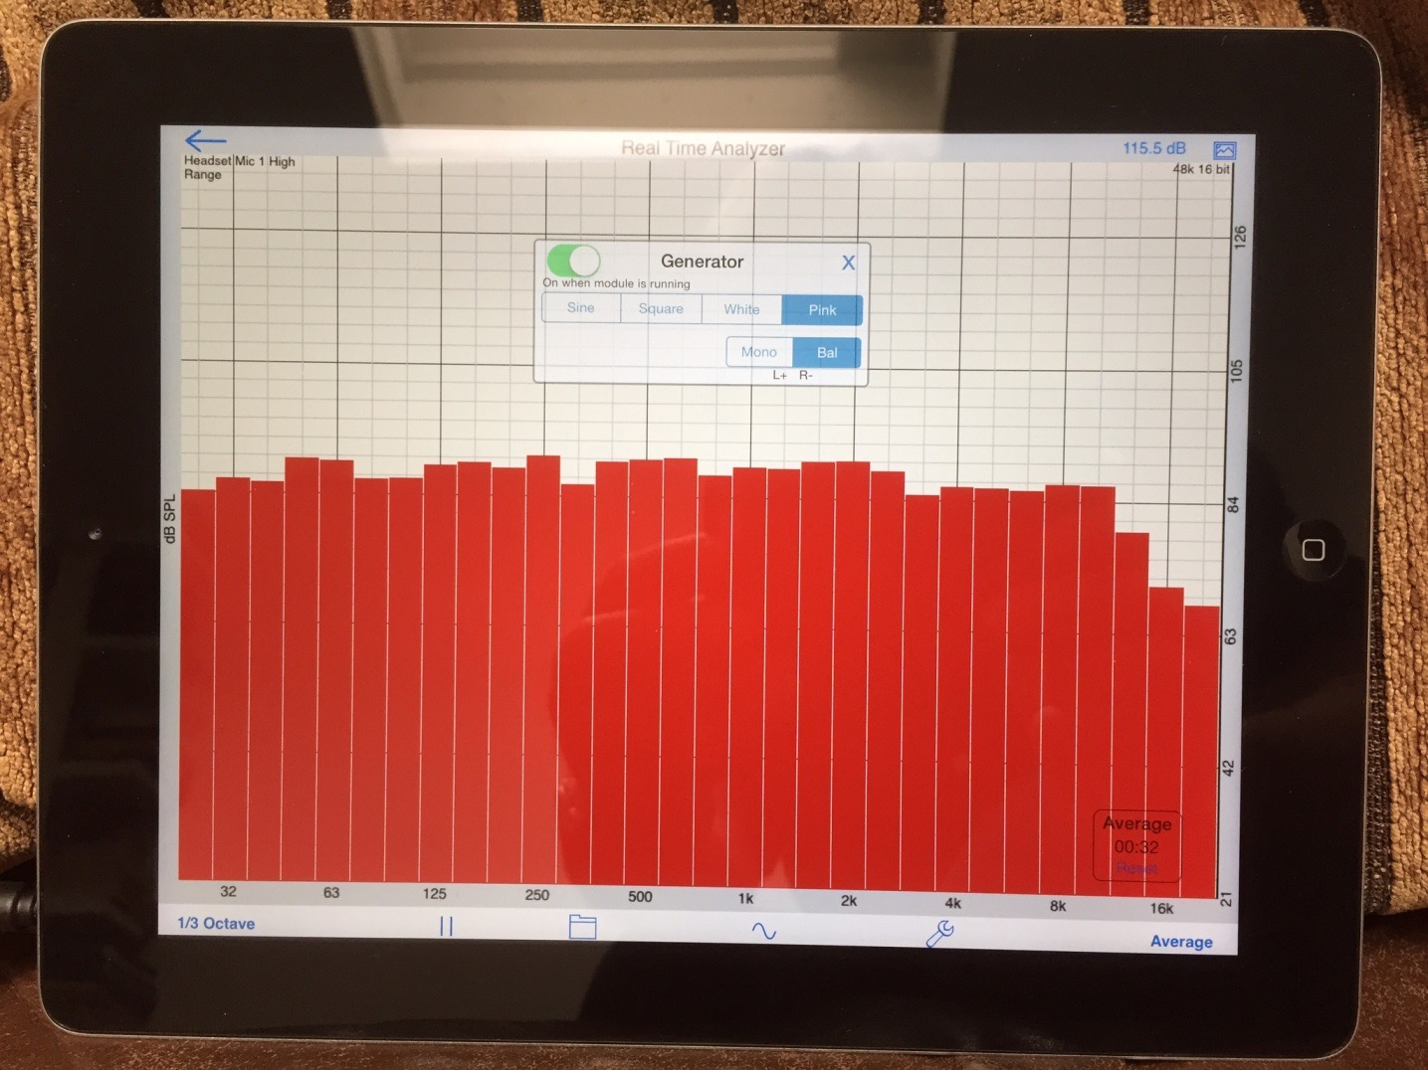

I do hope that above will be of some help to some !!

Good luck. Leon Huijgen.

